Hanoi University of Science and Technology
LAB INSTRUCTIONS
IT3080E COMPUTER NETWORKS
(For INternal Use only)
Update: 20/12/2022
School of Information and communication technology

© 2022 – HUST – SOICT

MỤC LỤC
1. Introduction 3
1.1. GOAL and scope 3
1.2. objectives of the lab 3
1.3. general information 3
2. REGULATIONS FOR STUDENTS 3
3. LAB 1: Building an Ethernet Cable 4
3.1. PURPOSE OF WORK 4
3.2. MAKE AND TEST YOUR CABLE 7
4 LAB 2: Layer 2 Network Design 11
4.1. PURPOSE OF WORK 11
4.1.3.1. basic switch configuration 11
4.1.3.1.1. Hostname 11
4.1.3.1.2. Turn Off Domain Name Lookups 11
4.1.3.1.3. Set the Domain Name 12
4.1.3.1.4. Configure console and other ports 12
4.1.3.1.5. Usernames and Passwords 12
4.1.3.1.6. Enabling login access for other devices 13
4.1.3.1.7. Configure system logging 13
4.1.3.1.8. Save the Configuration. 14
4.1.3.2. IP Address Configuration 15
4.1.4. Internet Protocol 15
4.1.5. Internet Control Message Protocol 17
4.2. PRACTICE STEPS 17
4.3. Report for LAB 2 18
LAB EXERCISE 3: STATIC ROUTING IN IP NETWORKS 20
5.1 Purpose and Content 20
5.2 LAB CONTENT 1: Setting Up the LAN 23
5.3 LAB CONTENT 2: Connecting Two LANs via Routers 26
LAB REPORT FOR EXERCISE 3 30
PRACTICAL EXERCISE NO. 4: ANALYSIS OF NETWORK SERVICE 32
1. Description 32
2. Background 32
3. Practical tasks 35

1. Introduction

1.1. GOAL and scope

1.2. objectives of the lab

1.3. general information
Workload: 5 labs * 3 periods/ lab

2. REGULATIONS FOR STUDENTS
- Comply with the regulations in the practice room
- Print lab instructions (including manuals and report templates), read them carefully and review relevant knowledge contents
- Bring the lab instructions when coming to practice classes.
- Do the exercises according to the instructions in the document. Do not perform contents other than the instructions, unless requested by the instructor
- Submit the lab report and other results as required and instructed at the end of the practice session
- Plagiarism in any form and for any reason will result in 0 score.

3. LAB 1: Building an Ethernet Cable

3.1. PURPOSE OF WORK
3.1.1. Objectives
- Study of technical data and designs of UTP Cat5 and Cat6 cables (twisted pair) used in computer networks.
- Exploring the EIA/TIA-568A/B standards for connecting the 8P8C connector (sometimes called RJ45) and the Twisted Pair cable.
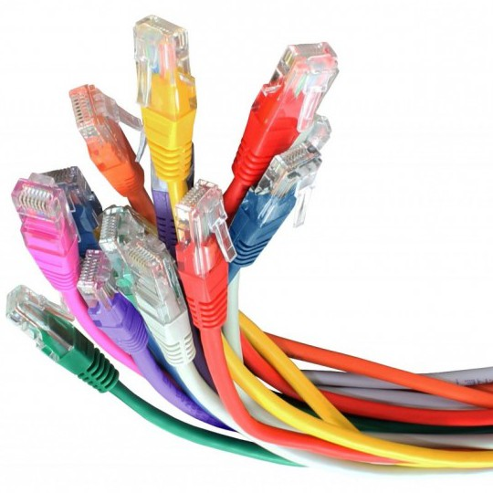
- Get the initial skills of crimping and testing UTP Cat5 network cable.
3.1.2. Required Resources
- Bulk Ethernet Cable
- RJ45 Crimpable Connectors for CAT-5e (or for CAT-6)
- Crimping Tool for RJ-45
3.1.3. Task for the work
- Study of technical data and designs of EIA/TIA-568A/B, UTP/STP, RJ45.
- Make and test Your Cable UTP Cat5e.
3.1.4. Theoretical basis
3.4.1.1. Types of Cables
- Cable Types by Wired
Both for internal (building cables) and for external wiring, three classes of wired communication lines are most often used
  - Twisted pair
  - Coaxial cables
  - Fiber optic cables

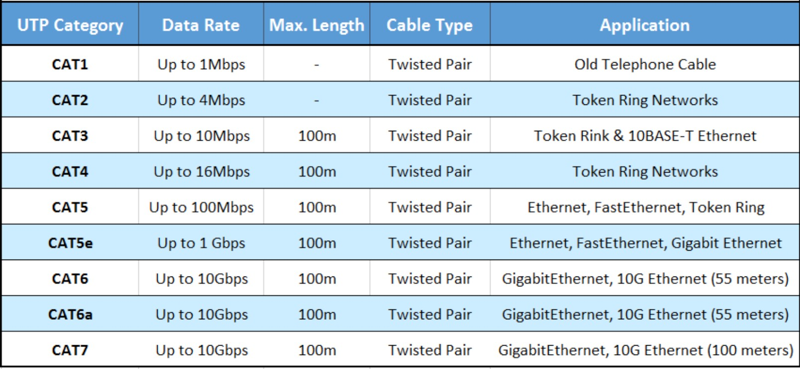
- Cable Types by UTP Categories

- Cable Types by Cross
There are two types of network cables
  - Direct cable (Direct Connection) - to connect a network card port to a switch or hub
  - A crossover cable with an inverted pinout of the connector for directly connecting two network cards installed in computers, as well as for connecting some older models of hubs and switches (uplink port).
There are some network cards that can automatically detect the type of cable and adapt to it.

- Cable Types by Crimping
There are two types of crimping (preparation) of the plug. In practice, the EIA / TIA-568B connection scheme is more often used.
  - EIA/TIA-568A
  - EIA/TIA-568B

- Ethernet UTP Cables Schemes
1Direct Cable Cat5/5e/6 EIA/TIA-568B
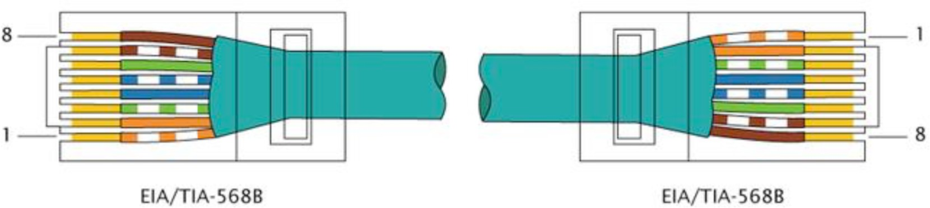
Direct Cable Cat5/5e/6 EIA/TIA-568A
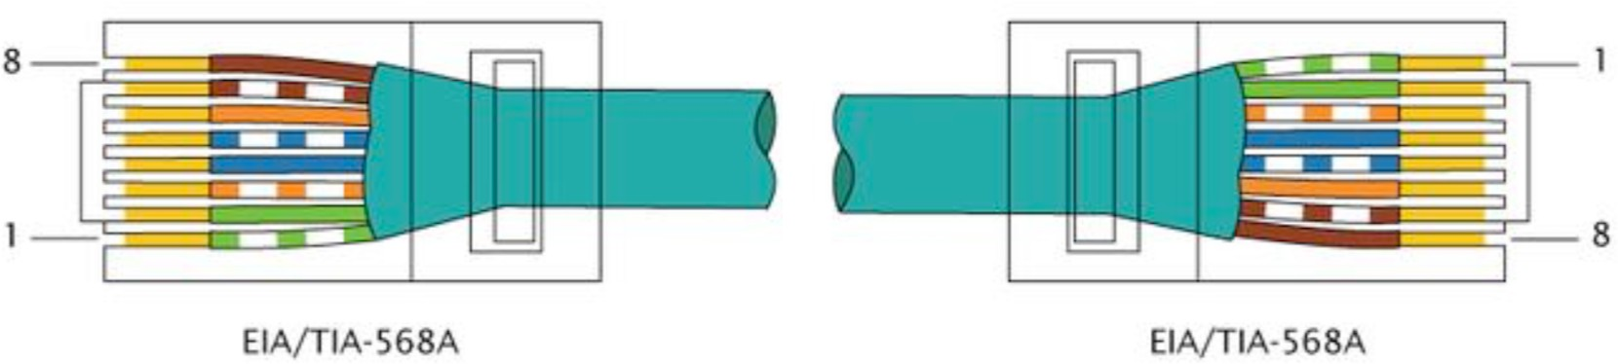
3Cross Cable Cat5/5e/6 EIA/TIA-568B/A (100MB/s)
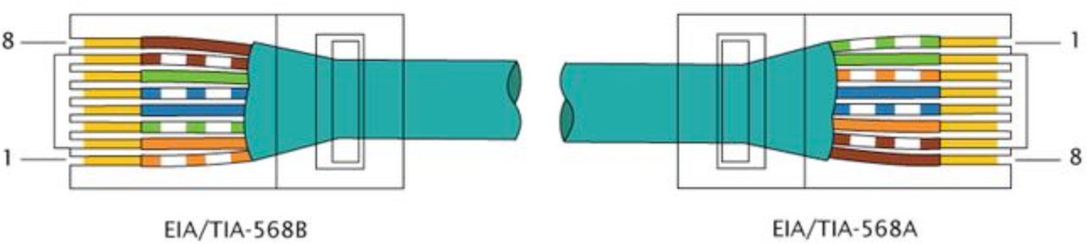
4Cross Cable Cat5/5e/6 EIA/TIA-568B/x (1000MB/s)
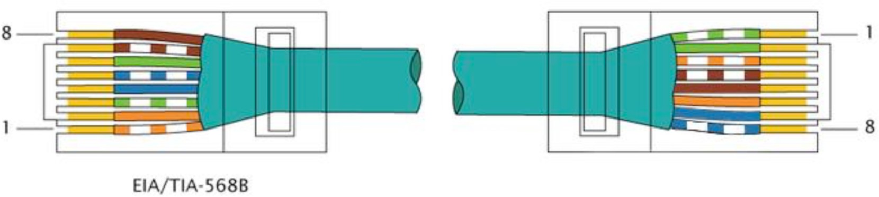
- SHORT FILMS ABOUT HANDMADE ETHERNET UTP/STP CABLES.
  - Terminating CAT5 Unshilded Cable with RJ45 Connector
https://www.youtube.com/watch?v=WvP0D0jiyLg
  - Terminating CAT6 Unshilded Cable with EZ-RJ45 Connector
https://www.youtube.com/watch?v=0vZs5oHyzgU
  - Terminating CAT6 Shielded Cable with RJ45 Connector
https://www.youtube.com/watch?v=-bQjrDirT6g

3.2. MAKE AND TEST YOUR CABLE
Step 1 | 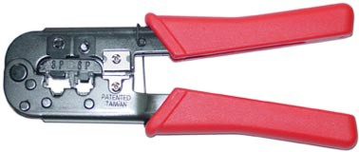 or  | Use Crimping Tool or Scissors, cut a cable 0.5 m long.
Step 2 | 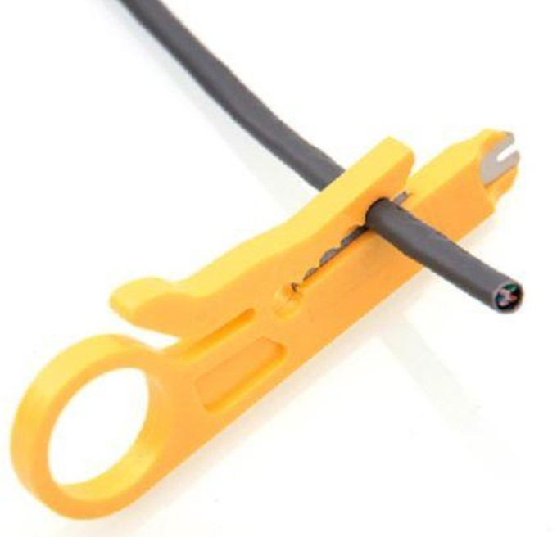 or | Use Crimping Tool or Cable Stripper clean the outer shell about 1 Inch (2.5 cm) from the one end of the cable.  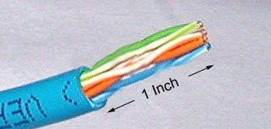
Step 3 | 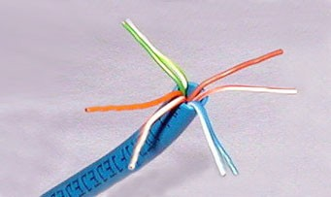 | Unwind and pair the similar colors.
Step 4 | 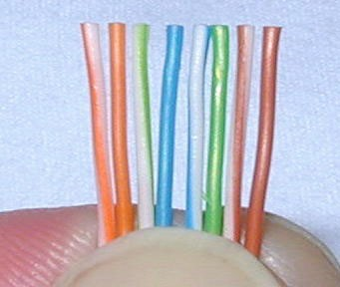 | Pinch the wires between your fingers and straighten them out as shown. The color order is important to get correct.  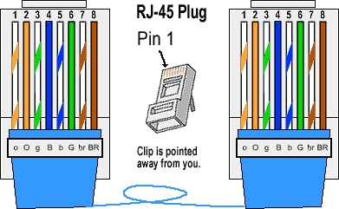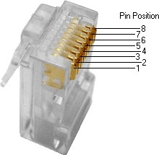
Step 5 | or | Use Crimping Tool or Scissors to make a straight cut across the 8 wires to shorten them to 1/2 Inch (1.3 cm) from the cut sleeve to the end of the wires.  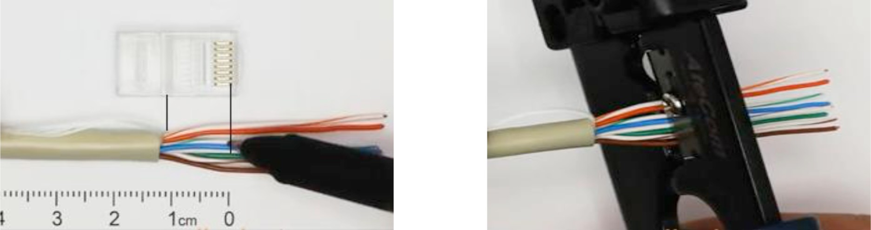
Step 6 | 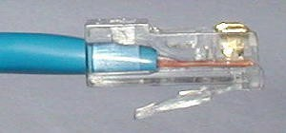 | Carefully push all 8 unstripped colored wires into the connector.  TRUE WAY - Note the position of the blue plastic sleeve.  Also note how the wires go all the way to the end.
 | 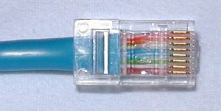 | TRUE WAY - A view from the top. All the wires are all the way in. There are no short wires.
 | 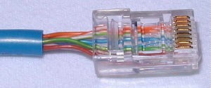 | WRONG WAY - Note how the blue plastic sleeve is not inside the connector where it can be locked into place. The wires are too long. The wires should extend only 1/2 inch from the blue cut sleeve.
 | 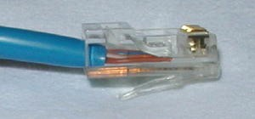 | WRONG WAY - Note how the wires do not go all the way to the end of the connector.
Step 7 | 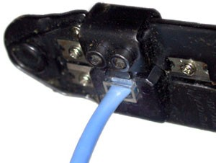 | CRIMPING THE CABLE ... carefully place the connector into the Ethernet Crimper and cinch down on the handles tightly. The copper splicing tabs on the connector will pierce into each of the eight wires. There is also a locking tab that holds the blue plastic sleeve in place for a tight compression fit. When you remove the cable from the crimper, that end is ready to use.
Step 8 | 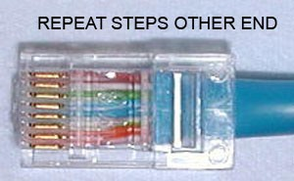 | For a standard "Direct" cable, repeat steps 2-7.  (For a Cross-over cable, the other end will have a different color order as shown by the crossover pictures above.)
3.3. Test Your Cable
- Use the cable tester, test the crossover cable for functionality. If it fails, check with your instructor first as to whether you should re-cable the ends and re-test
- Connect two PCs together via NICs using your Ethernet cable
3.4. Reflection
- Which part of making cables did you find the most difficult?
- Why do you have to learn how to make a cable if you can easily buy pre-made cables?

4 LAB 2: Layer 2 Network Design

4.1. PURPOSE OF WORK
4.1.1. Objectives
- Build Layer 2 (switched) networks
- Students will see how star topology, and Spanning Tree Protocol are put to work.
4.1.2. Required Resources
- Switch cisco 2960c
- Switch TP link 4 FE ports
- Console cable to config switch from CLI
- PCs
- Software: cisco_usbconsole_driver_3_1.zip and terminal emulator (Putty)
4.1.2. Task for the work
- Understand how to config a switch, assign IP to a switch
- Knowledge: IP, subnet mask
- Make a report
4.1.3. Theoretical basis
      - basic switch configuration

Hostname
Your switches should be given a basic configuration as follows:
Router> enable
Router# config terminal
Enter configuration commands, one per line. End with CNTL/Z.
Router(config)# hostname dist1-b1.campusX
dist1-b1.campusX(config)#

Turn Off Domain Name Lookups
Cisco devices will always try to look up the DNS for any name or address specified in the command line. You can see this when doing a trace on a router with no DNS server or a DNS server with no in-addr.arpa entries for the IP addresses. We will turn this lookup off for the labs for the time being to speed up traceroutes.
dist1-b1.campusX(config)# no ip domain lookup

Set the Domain Name
We will now set the domain name of our campus devices, for future use in this workshop.
dist1-b1.campusX(config)# ip domain name ws.nsrc.org

Configure console and other ports
By default, Cisco devices will try all transports available if they don’t recognise what is typed into the command line. This behaviour is annoying especially if making a typo during configuration work, so we will disable the behaviour completely. We will also set the idle-timeout on the console and other ports to 30 minutes - after 30 minutes of no activity on the port, the device will disconnect the connection.
dist1-b1.campusX(config)# line con 0
dist1-b1.campusX(config-line)# transport preferred none
dist1-b1.campusX(config-line)# exec-timeout 30 0
dist1-b1.campusX(config-line)# line aux 0
dist1-b1.campusX(config-line)# transport preferred none
dist1-b1.campusX(config-line)# exec-timeout 30 0
dist1-b1.campusX(config-line)# line vty 0 4
dist1-b1.campusX(config-line)# transport preferred none
dist1-b1.campusX(config-line)# exec-timeout 30 0

Usernames and Passwords
All router usernames should be cndlab with password being lab-PW. The enable password (which takes the operator into configuration mode) needs to be lab-EN1.
Please do not change the username or password to anything else, or leave the password unconfigured (access to vty ports is not possible if no password is set). It is essential for a smooth operating lab that all participants have access to all routers.
dist1-b1.campusX(config)# username cndlab secret lab-PW
dist1-b1.campusX(config)# enable secret lab-EN
dist1-b1.campusX(config)# service password-encryption
The service password-encryption directive tells the router to encrypt all passwords stored in the router’s configuration (apart from enable secret2 which is already encrypted).

Enabling login access for other devices
In order to let you telnet into your device in future modules of this workshop, you need to configure a password for all virtual terminal lines.
dist1-b1.campusX(config)# aaa new-model
dist1-b1.campusX(config)# aaa authentication login default local
dist1-b1.campusX(config)# aaa authentication enable default enable
This series of commands tells the router to look locally for standard user login (the username password pair set earlier), and to the locally configured enable secret for the enable login. By default, login will be enabled on all vtys for other teams to gain access.

Configure system logging
A vital part of any Internet operational system is to record logs. The router by default will display system logs on the router console. However, this is undesirable for Internet operational routers, as the console is a 9600 baud connection, and can place a high processor interrupt load at the time of busy traffic on the network. However, the router logs can also be recorded into a buffer on the router – this takes no interrupt load and it also enables to operator to check the history of what events happened on the router.
dist1-b1.campusX(config)# no logging console
dist1-b1.campusX(config)# logging buffer 8192 debug
which disables console logs and instead records all logs in a 8192 byte buffer set aside on the router. To see the contents of this internal logging buffer at any time, the command show log should be used at the command prompt.
And we also want to set up improved time-stamping for the log messages as well:
service timestamps debug datetime msec localtime show-timezone year
service timestamps log datetime msec localtime show-timezone year
which will give resolution down to milliseconds, and include the year as well.

Save the Configuration.
With the basic configuration in place, save the configuration. To do this, exit from enable mode by typing end or <ctrl>Z, and at the command prompt enter write memory.
dist1-b1.campusX(config)# end
dist1-b1.campusX# write memory
Building configuration...
[OK]
dist1-b1.campusX#
It is highly recommended that the configuration is saved quite frequently to NVRAM. If the configuration is not saved to NVRAM, any changes made to the running configuration will be lost after a power cycle or virtual machine failure
Log off the switch:
dist1-b1.campusX# exit
and then log back in again. Notice how the login sequence has changed, prompting for a username and password from the user, like this:
dist1-b1.campusX con0 is now available

Press RETURN to get started.

User Access Verification

Username:
Note that at each checkpoint in the workshop, you should save the configuration to memory – remember that powering the device off will result in it reverting to the last saved configuration in NVRAM.

IP Address Configuration
Assign a switch an IPv4 address (and IPv6 address) as follows:
interface vlan 1
ip address 172.2X.0.N 255.255.0.0
ipv6 address 2001:DB8:X:1::N/64
load-interval 30
no shutdown
end
Replace the X with your group number, and N with the address according to the address plan earlier in the notes. Note the load-interval command which will calculate the average traffic load on the interface over a 30 second period (rather than over the default 5 minutes).
- For some unknown reason, the switch on rare occasions will add static MAC entries. These often point to the wrong interface. If you have entries like these in your configuration, trying shutting down the VLAN 1 interface mentioned, deleting the line by putting a no in front of the offending configuration, and then bringing the VLAN 1 interface back up again. If that doesn't work (the mac-address-table line is still there), ask your lab instructor.

Internet Protocol
- The Internet Protocol (IP) is a protocol, or set of rules, for routing and addressing packets of data so that they can travel across networks and arrive at the correct destination. Data traversing the networks is divided into smaller pieces, called packets. IP information is attached to each packet, and this information helps routers to send packets to the right place. Every device or domain that connects to the Internet is assigned an IP address, and as packets are directed to the IP address attached to them, data arrives where it is needed.
- Once the packets arrive at their destination, they are handled differently depending on which transport protocol is used in combination with IP. The most common transport protocols are TCP and UDP.
- IP packets are created by adding an IP header to each packet of data before it is sent on its way. An IP header is just a series of bits (ones and zeros), and it records several pieces of information about the packet, including the sending and receiving IP address. In total there are 14 fields for information in IPv4 headers, although one of them is optional.
- IP provides mechanisms that enable different systems to connect to each other to transfer data. Identifying each machine in an IP network is enabled with an IP address. IPv4 provides a 32-bit IP addressing system that has four sections. For example, a sample IPv4 address might look like 192.168.0.1, which coincidentally is also commonly the default IPv4 address for a consumer router. IPv4 supports a total of 4,294,967,296 addresses. Traditionally, IPv4 has 5 categories namely A, B, C, D, E as shown in the following picture:
- 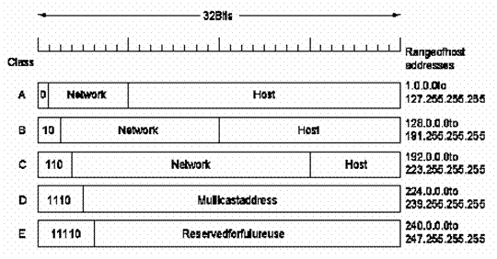
- Since the internet must accommodate networks of all sizes, an addressing scheme for a range of networks exists based on how the octets in an IP address are broken down. You can determine based on the three high-order or left-most bits in any given IP address which of the five different classes of networks, A to E, the address falls within. Subnetting is the technique for logically partitioning a single physical network into multiple smaller sub-networks or subnets. A subnet mask is a 32-bit number created by setting host bits to all 0s and setting network bits to all 1s. In this way, the subnet mask separates the IP address into the network and host addresses. IPv4 addresses represented in CIDR notation are called network masks, and they specify the number of bits in the prefix to the address after a forward slash (/) separator

Internet Control Message Protocol
- The Internet Control Message Protocol (ICMP) is a network layer protocol used by network devices to diagnose network communication issues. ICMP is mainly used to determine whether or not data is reaching its intended destination in a timely manner. Commonly, the ICMP protocol is used on network devices, such as routers.
- The primary purpose of ICMP is for error reporting. When two devices connect over the Internet, the ICMP generates errors to share with the sending device in the event that any of the data did not get to its intended destination.
- A secondary use of ICMP protocol is to perform network diagnostics; the commonly used terminal utilities traceroute and ping both operate using ICMP. The traceroute utility is used to display the routing path between two Internet devices.

4.2. PRACTICE STEPS
- The following diagram shows the flat network we have just built
- Assign each computer a different IPv4 address as shown in the diagram.
- On PC1 with the IP of 192.168.1.2 create a connection to control the switch using ssh tool.

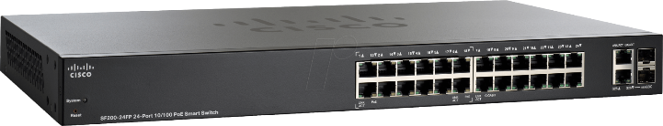
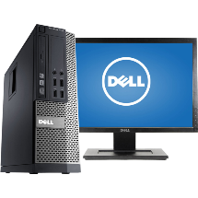
PC1
192.168.1.2/24
PC2
192.168.1.3/24
PC3
192.168.254.2/24
PC4
172.168.1.5/16

Report for LAB 2
Student name: Student ID:
Practice Course code: Theory Course code:
IP of PC:

Experiment (3 điểm)
Student connects to a switch and collect information of MAC address that connect to the PC1 and PC3 at two points of time: before and after sending packets from PC1 to PC3 and vice versa.
The command to see the MAC address for port 1 (i.e., Gi0/3), the MAC address is stored in the MAC table in the switch, is as follow:
c2960#sh mac address-table interface Fa0/1
Mac Address Table
-------------------------------------------
Vlan Mac Address Type Ports
---- ----------- -------- -----
32 68b5.99fc.d1df DYNAMIC Fa0/1
Total Mac Addresses for this criterion: 1

Use the diagram given in the section 4.2.1, fill in the following table in 3 cases:
- PC1 ping PC2
- PC2 ping PC3
- PC3 ping PC4
Port | Before pinging PC1->PC2 | After pinging PC1->PC2
Fa0/1 | Empty | MAC: 68b5.99fc.d1df  Port: Fa0/1  MAC: 001b.10ae.7d00  Port: Fa0/2

LAB EXERCISE 3: STATIC ROUTING IN IP NETWORKS

5.1 Purpose and Content
5.1.1 Purpose
This lab equips students with practical skills in intra-domain routing so that they can configure static routing for computer networks using IP routers. This ensures data transmission between networks and allows for Internet connectivity. Specifically, students will practice with IP addresses, routing tables, configuration tools and commands, and connection testing.
5.1.2 Student Requirements
Theoretical Knowledge:
- Understand IP routing principles.
- Understand how routers operate based on routing tables.
- Understand how routing tables are set up.
- Understand IP address allocation rules.
Attention: Students must prepare IP allocation plan at home before the lab.
Practical Skills:
- Connect networking devices (switches, routers) to form interconnected subnets.
- Proficiently configure static routing tables using Linux routers.
Required Deliverables:
- Demonstrate connectivity checks at the end of sections 5.2.1 and 5.2.2 to the teaching assistant (2/10 points).
- Submit a printed report with answers to the provided questions (8/10 points).
5.1.3 Theoretical Background
5.1.3.1 IP Address
Each computer on the Internet is assigned an IP address. An IPv4 address consists of 4 bytes, e.g., 10000010 10001010 00001000 00000001, or in decimal dot format: 130.238.8.1.
An IP address consists of two parts: network ID (left-side bits) and host ID (right-side bits). The boundary between these parts is defined either by:
- Classful addressing (A, B, C, D, E), or
- Subnet masks specifying how many leftmost bits represent the network ID.
For example, a subnet mask of 24 means 24 bits for network ID. In binary: 11111111 11111111 11111111 00000000, or in decimal: 255.255.255.0.
With an 8-bit host ID (32-24), the subnet supports 2⁸ = 256 IP addresses. Excluding the network address (all host bits 0) and broadcast address (all host bits 1), 254 usable IPs remain.
5.1.3.2 Internetworking and Routing
The Internet comprises many interconnected LANs. Data transfer between these LANs is enabled via IP forwarding, executed by routers.
A router has at least two interfaces connected to different LANs. It receives IP packets on one interface and forwards them through another based on destination addresses, determined via routing tables.
Routing tables are built based on network topology and must be updated to reflect changes. In small networks, routing tables can be manually created (static routing) or dynamically configured using protocols like RIP or OSPF.
5.1.3.3 Routing Tables and Configuration Commands
Routing table format: [Destination, Netmask, Cost, Next hop, Interface]
Example:
169.254.0.0 255.255.0.0 1000 0.0.0.0 eth0
192.168.6.0 255.255.255.0 0 0.0.0.0 eth1
192.168.122.0 255.255.255.0 0 0.0.0.0 eth2
0.0.0.0 0.0.0.0 0 0.0.0.0 eth2
Routing decisions use the "longest matching prefix" rule. If no match is found, the default route (0.0.0.0/0) is used. If no default exists, packets are dropped.
Linux interface names are usually ethX (e.g., eth0, eth1).
To view interfaces:
$ ifconfig
To activate an interface and assign to it an IP address:
$ ifconfig eth0 192.168.200.1 netmask 255.255.255.0 up
This command activates the interface eth0 and assign it the IP address 192.168.200.1
To view/add routes:
$ route
For example, add a specific route to the 192.168.205.0 network by forwarding data to the next-hop node with the address 192.168.200.1, which is directly connected to the computer through a network interface.
$ sudo route add -net 192.168.205.0 netmask 255.255.255.0 gw 192.168.200.1
To add a default route to all networks by forwarding data to the next-hop node 10.1.0.1, which is directly connected to the computer through a network interface."
$ sudo route add default gw 10.1.0.1
To show routing table
$ route -n
To print the route to a host
$ traceroute
Ex: $ traceroute -n -z 1 192.168.205.1
Use man to see instruction of the above commands.
Note: The term "gateway" refers to a router that acts as the entry/exit point of a network.
Following commands are usually used on Mikrotik Router BR4011 series, the router will be provided to work in this lab. To connect to Router BR4011 series, look at the instruction in the appendix slides.
Test a connection to a host
ping
Setup IP address for an interface
ip/address/add address=<ip_address/mask> interface=<port>
Use “tab” to see the list of ports can be entered as parameters, ports on router are numbered and the values usually correspond to the number on the ports
List all IP addresses that are setup to an interface.
Ip/address/print
Remove an IP address from some interfaces
ip/address/remove numbers=<number of the line where the address appear when using the print command above>
Add a static route to the router
ip/route/add dst-address=<ip_address/mask> gateway=<port or ip_next_hop>
Show all routes on the router
ip/route/print
Delete an existing route
ip/route/remove numbers=<number of the line where the route appear when using the print command above >

5.2 LAB CONTENT 1: Setting Up the LAN
Students are divided into groups of 4 students. Each group is provided with 1 Router Mikrotik BR4011, 1 switch to make one LAN, 3 PCs to act as 3 workstations and USB Ethernet to add more network port to PCs.

A company has two branches in Hanoi and Saigon, each requiring its own LAN. The Hanoi LAN can only be accessed via a machine named hn-workstation, while the Saigon LAN via sg-workstation. Workstations in each LAN are connected to a switch. Each LAN can communicate internally, but not with the other branch. Each LAN is connected to a router for future external connections, as shown in the diagrams.
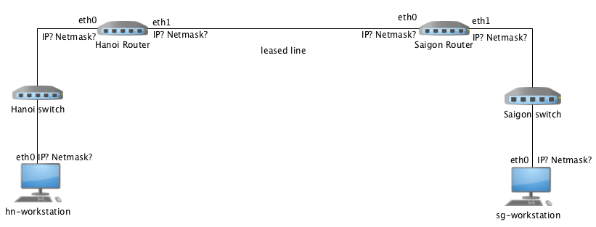
Fugure 1: LAN in Hà nội
Figure 2: LAN in Sài gòn

IP ranges:
- Saigon: 10.1.0.0, mask 255.255.0.0
- Hanoi: 10.2.0.0, mask 255.255.0.0
5.2.1 IP Address Planning
Interfaces of workstations and of routers are connected to the same switch, so they must be on the same subnet.
Question 1 (1 point): Assign appropriate IP addresses to sg-workstation, hn-workstation, and router interfaces. Fill in the diagram.
IP hn-workstation: ..........................................................Netmask:.............................................
IP sg-workstation: ................................... ………………. Netmask:..............................................
IP for router Hanoi-eth0: .................................... ................... Netmask:..............................................
IP for router Saigon-eth1: .............................. ....................... Netmask:..............................................
5.2.2 Connection and Configuration
Goal: Establish the network connections per the diagrams in Figure 1 and Figure 2, and make necessary configurations so that each LAN's workstation can communicate with its own router. To do so, students need to configure according to the following steps.
Note: To do this exercise, students need to use admin role when executing commands (root permission or use sudo command)
Steps 1: Connect devices as shown in the diagrams.
Step 2: Configure IP addresses for workstations and router interfaces. Tasks to be done in this step include:
- Configure the IP address for the workstation according to the IP addressing scheme in section 5.2.1.1
- Configure the IP address for the router's interface according to the IP addressing scheme in section 5.2.1.1
Question 2 (1 point): Use ifconfig to activate and assign IPs to interfaces as per your IP plan.
Hà nội workstation:
...................................................................................................................................................... .
Sài gòn workstation:
......................................................................................................................................................
Question 3 (1 point): Use commands to set IP addresses on the router interfaces.
Hà nội router:
...................................................................................................................................................... .
Sài gòn router:
.....................................................................................................................................................
Step 3: Set Routing Rules on Workstations
- Each workstation must know it can reach its local subnet directly. This rule is usually auto-added when an interface is enabled. Check using: $ route -n
Question 4 (1 point): Verify routing rules on workstations using route -n. The result is:
………………………………………………………………………………………………
Question 5 (1 point): Use ping to test if each workstation can reach its own router (demo with Teaching assistant is required).

5.3 LAB CONTENT 2: Connecting Two LANs via Routers
The goal of this lab session is to connect the two LANs created in the previous section and configure routing so that the computers in both networks can send data to each other.
Similar to Lab 1, students will be divided into groups of 4 and each group is provided with 1 Router Mikrotik BR4011, 1 switch to make one LAN, 3 PCs to act as 3 workstations and USB Ethernet to add more network port to PCs.
In order for the two headquarters to transfer data between each other, a leased line is established between the Saigon and Hanoi headquarters. Use a single cable to create the leased line connection between the remaining ports of the Hanoi Router and Saigon Router, as shown in the diagram below. Additionally, the configurations on the routers and workstations need to be adjusted so that computers from both LANs can communicate with each other following the steps below.
Figure 3: Diagram showing the connection between Hanoi and Saigon branches
Step 1: Router Configuration
- Assign IPs to interfaces on workstations and routers, write the interfaces to the figure.
Attention: Interfaces connected to the same switch must be on the same subnet (e.g., their IP addresses should have the same Network ID part).
Step 2: Configure the routers
- Set IP for the router interfaces connected to the leased line.
Attention:The two interfaces of the two routers connected to each other on the leased line can have arbitrary addresses, but they must belong to the same network. That is, their IP addresses must have the same network ID.
Question 6 (1 point): Choose IPs for router interfaces on the leased line.
IP of Hanoi-eth1: .......................................................... Netmask:........................................
IP of Saigon-eth0: ........................................................ Netmask:..........................................
Question 7 (1 point): Write down the commands to set these IPs on router’s interfaces that connect to the leased line.
router Hà nội :
............................................................................................................................................................
router Sài gòn:
............................................................................................................................................................
- Set routing tables on the routers to forward packets between LANs.
Question 8 (1 point):
Add a route on the Hanoi router to reach Saigon LAN.
............................................................................................................................................................
Add a route on the Saigon router to reach Hanoi LAN.
............................................................................................................................................................
Step 3: Adjust Routing Rules on Workstations
Workstations don’t yet know how to send packets outside their own LANs. In this step, we adjust routing tables of workstations to tell them to forward the packets, that do not head to local networks, to the routers. Two options to do that:
- Add static routes to remote networks.
- Add a default route via the local router.
Question 9 (1 point): Set routing rules on workstations:
Check current routes with route -n command
Use route add command to add static/default routes to the remote LANs.
Command on hn-workstation to add route to LAN saigon or default route:
…………………………………………………………………………………………………….
Command on sg-workstation to add route to LAN hanoi or default route:
…………………………………………………………………………………………………….

Step 4 (1 point): Connection Check (demo required)
If configured correctly, workstations can now communicate. Use traceroute to verify connectivity between hn-workstation and sg-workstation
The result could be similar to the following:
sg-workstation:~# traceroute -n -z 1 10.2.0.10
traceroute to 10.2.0.10 (10.2.0.10), 30 hops max, 38 byte packets
1 10.1.0.1 2.600 ms 0.831 ms 0.802 ms
2 10.10.0.2 3.517 ms 1.161 ms 1.156 ms
3 10.2.0.10 7.695 ms 1.528 ms 1.514 ms
sg-workstation:~#

LAB REPORT FOR EXERCISE 3
Name………………………………………………………………………………………..
StudentID:…………………………………………………………………………………..
Lab Class ID: ……………………………………………………………………………………
Theory Class ID: ………………………………………………………………………………..
Question 1 (1 point): Assign IPs and fill in diagram.
- hn-workstation: ………………………….. Subnet Mask: …………………………………
- sg-workstation: …………………………… Subnet Mask: ……………………………….
- router Hanoi-eth0: ………………………… Subnet Mask:……………………………….
- router Saigon-eth1: ………………………….Subnet Mask: ……………………………..
Figure 3: Network topology.
Question 2 (1 point): Use ifconfig commands to set IPs:
- hn-workstation: …………………………………………………………………………..
- sg-workstation: …………………………………………………………………………..
Question 3 (1 point): IP setup commands for router interfaces:
- router Hanoi: …………………………………………………………………………..
- router Saigon: …………………………………………………………………………..
Question 4 (1 point): Output of route -n on workstation:
…………………………………………………………………………..
Question 6 (1 point): Choose IPs for leased line interfaces:
- router Hanoi-eth1: ……………………………… Subnet Mask:………………………
- router Saigon-eth0……………………………… Subnet Mask:………………………
Question 7 (1 point): Commands to set IP addresses to the interfaces that are connected to the leased line:
- router Hanoi: …………………………………………………………………………..
- router Saigon: …………………………………………………………………………..
Question 8 (1 point): Add routes on router Hanoi so that it can send data to router Saigon:
- On Hanoi router:…………………………………………………………………………..
Add routes on router Saigon so that it can send data to router Hanoi:
- On Saigon router: …………………………………………………………………………..
Question 9 (1 point): Add static/default route on workstations:
Check the routing table.
Use the command to add a static route to a remote network. Execute the command on hn-workstation to route to the Saigon network or add a default route:
- hn-workstation: …………………………………………………………………………..
Execute the command that needs to be run on the sg-workstation machine to route to the data to Hanoi network or add a default route:
- sg-workstation: …………………………………………………………………………..

PRACTICAL EXERCISE NO. 4: ANALYSIS OF NETWORK SERVICE

1. Description
1.1. Purpose
This practical exercise is designed to equip students with skills in using Wireshark software to capture and filter packets when using domain name resolution services and Web services. Through this, students can observe and understand the important operations of these two services. Additionally, by applying theoretical knowledge, students can explain the observed results.
1.2. Requirements
- Practical environment:
- Proficient use of basic functions of Wireshark software
- Proficient execution of operations on Windows operating system, including TCP/IP parameter configuration operations that have been guided in previous practical exercises.
- Knowledge:
- Solid understanding of transport layer knowledge, UDP and TCP protocols
- Solid understanding of application layer knowledge, DNS and HTTP protocols.
- Write a report and submit results as follows:
- Report (paper version) according to the provided template
- Lab05.pcapng traffic file placed in a folder named StudentName_StudentID_Lab05. Compress the folder and send it to the email address as required by the instructors.

2. Background
2.1. UDP protocol
UDP (User Datagram Protocol) is one of protocols at the transport layer in the TCP/IP model. UDP operates on the principle of connectionless communication. Accordingly, the UDP protocol receives data from application layer processes, encapsulates it into UDP datagrams (UDP packets), and sends them directly to the destination without establishing a connection. UDP packets are received and processed independently by the destination. If a packet has no errors, UDP will deliver it to the corresponding application layer process; otherwise, it will discard the packet. Additionally, in any case, no acknowledgment packet is sent back to the source. This leads to another important characteristic of UDP: unreliable communication, meaning that UDP's control process doesn't guarantee successful data delivery to the destination. In other words, the source only transmits data once and doesn't need to know whether the data was successfully transmitted. This transmission mode is called best-effort mode. Furthermore, UDP continuously transmits data at the highest possible speed. This can increase the risk of congestion on the transmission line or overload the destination, making it unable to process received data in a timely manner.
2.2. TCP protocol
TCP (Transmission Control Protocol) operates in a much more complex manner compared to UDP. First, TCP follows the principle of connection-oriented communication, where the transmission process consists of 3 phases: connection establishment, data transmission, and connection termination. To manage and report connection status between parties, the TCP protocol designs packets with control flags in the header.
The significance of the connection establishment process in TCP is that the source only sends data when the destination is ready. This process follows the three-way handshake protocol:
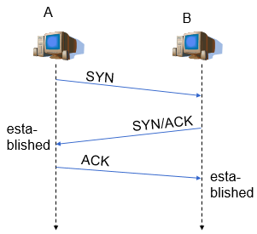
- Step 1: The requesting party (A) sends a TCP packet with no payload and the SYN flag set in the packet header.
- Step 2: If the responding party (B) is ready to establish a connection, it sends a packet with both SYN and ACK flags set. This packet also has no payload.
- Step 3: The requesting party sends a packet with the ACK flag set to confirm the connection has been established. This packet may contain payload.
On the established connection, data from the application layer process is encapsulated by TCP into TCP segments and transmitted using byte stream technique. In this technique, the source assigns sequence numbers to the packets sent, and the receiver, if necessary, arranges these packets in the correct order and combines them into a message to be sent to the application layer process. With this transmission method, it's possible that a message will be attached to data from other messages, meaning the boundaries between messages are not clear. Application layer processes must use some method to separate the messages.
Additionally, TCP is a reliable communication protocol. The sender always knows whether the data it transmits is successfully transmitted or not. This is because the TCP protocol requires that the destination send acknowledgment packets to the source with the ACK flag set. In the header of this packet, the ACK Number value indicates the sequence number of the data that the destination needs to receive. If the source determines that an error has occurred, the previous data will be resent; otherwise, the next data is sent. After completing the data transmission, the parties perform reliable connection termination operations by sending packets with the FIN flag set, ensuring all data has been successfully received.
Finally, to prevent transmission from congesting the network and overloading the destination, the TCP protocol uses congestion control and flow control mechanisms to limit the size of data sent in a single transmission.
2.3. Domain Name System
A domain name is a character string identifying a network node, consisting of labels separated by dots, for example, soict.hust.edu.vn is the domain name for the Web server of the School of Information and Communication Technology, Hanoi University of Science and Technology. For users, instead of having to remember IP addresses which are difficult-to-remember numerical values, users can access services using the server's domain name. However, during the transmission process, network nodes use IP addresses. Therefore, domain names need to be mapped to one or more IP addresses. On the Internet, domain names and these mappings, along with other information, are managed by servers in the DNS (Domain Name System). Additionally, these DNS servers provide domain name lookup services. When a network node wants to send information to another network node but only knows its domain name, it must perform a domain name lookup process. In most cases, this process begins with the client sending a DNS Query message to the DNS server. The search result is encapsulated in a DNS Response message and returned to the client. Typically, the DNS protocol uses the UDP protocol of the transport layer to transmit messages with the standard service port number on the server being 53.
2.4. World Wide Web and HTTP
The World Wide Web, abbreviated as Web, was first introduced by Tim Berners-Lee in 1991 with the main idea of linking information on the Internet via URL (Uniform Resource Location) and presenting it as a document using HTML (Hyper Text Markup Language) code called a Webpage. A collection of Webpages stored on a Web server forms a Website. Users can easily use a Web browser as a client software to access the Website. Although it emerged later than other traditional services on the Internet, such as email or file transfer, thanks to its ease of linking and sharing information, the Web quickly became popular and developed at a rapid pace. To this day, the Web is both the most popular service on the Internet and a platform for developing other services.
The HTTP protocol was developed by Tim Berners-Lee to control the operation of Web services. Compared to the HTTP 0.9 and HTTP 1.0 versions in the previous stage, the current HTTP 1.1 version has many improvements to enhance service performance. However, the basic principles of operation remain unchanged. HTTP is a connection-oriented protocol, using the service of the TCP protocol at the transport layer to establish connections and control the transmission of HTTP messages on that connection. The Web server uses port number 80 to listen for connection establishment requests sent from clients. To request Website content, the client sends an HTTP Request message and waits to receive an HTTP Response message. Currently, due to security issues, the HTTPS protocol is gradually being replaced to ensure the security of the transmission process in Web services. HTTPS is an improvement of HTTP, where SSL/TLS connections are used instead of TCP connections and the application port number is 443. On the SSL/TLS connection, HTTP messages will be encrypted to protect the confidentiality and integrity of the data.

3. Practical tasks
3.1. Environment Preparation
- Step 1: Press the Windows key on the keyboard, search for "Settings," and select the Settings option.
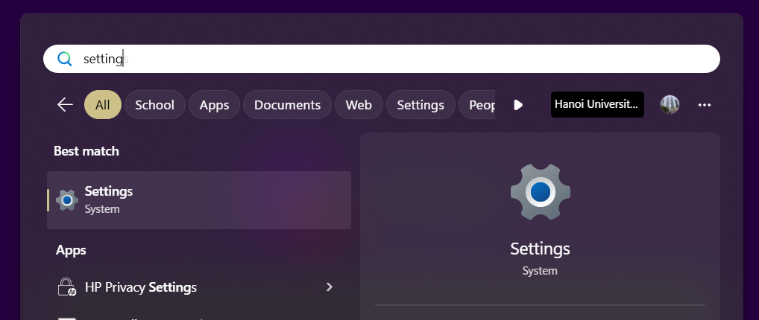
- Step 2: In Settings, select Network & Internet. Then, choose the network connection currently in use by your computer.
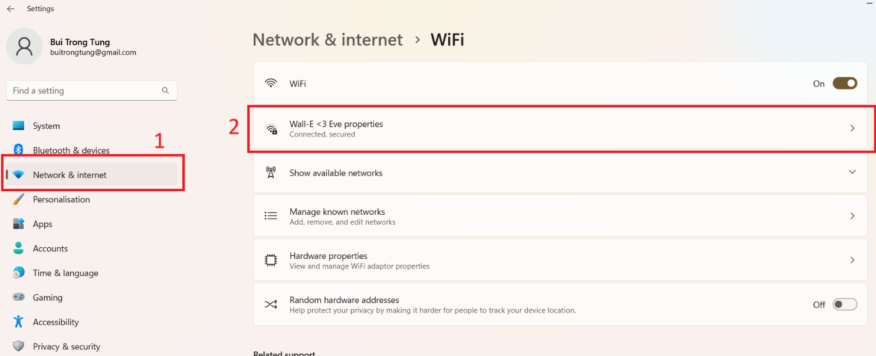

- Step 3: Under DNS server assignment, click the Edit button.
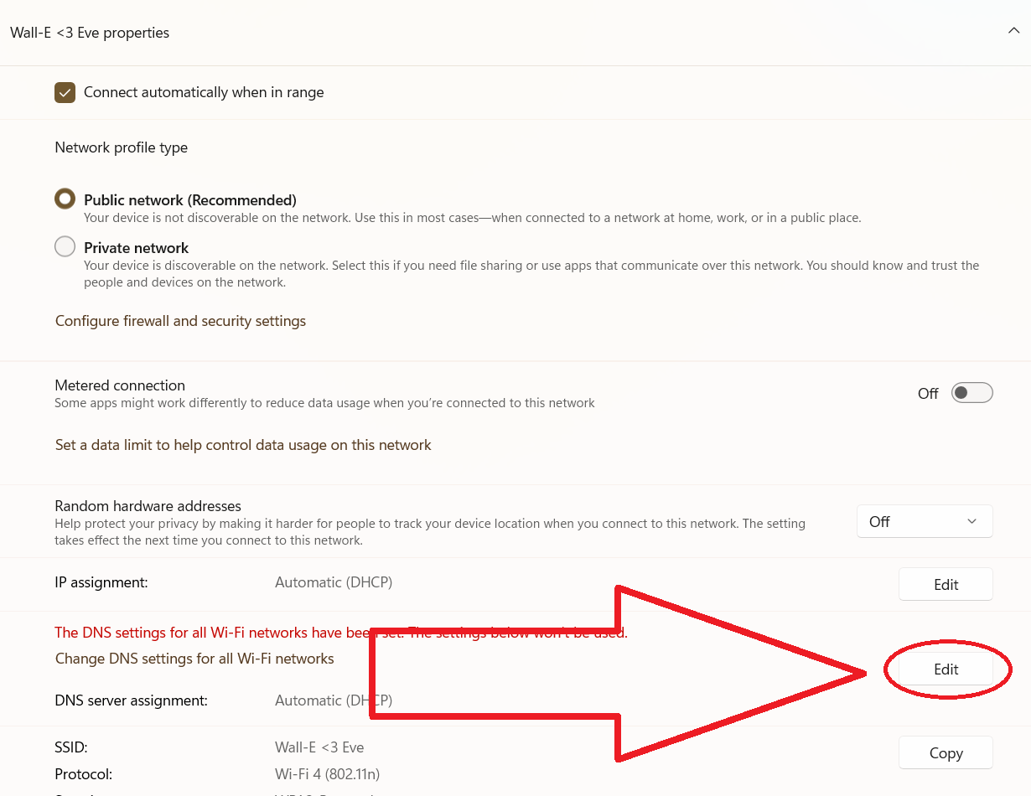
- Step 4: Configure the DNS service parameters as shown in the figure below. Click Save.
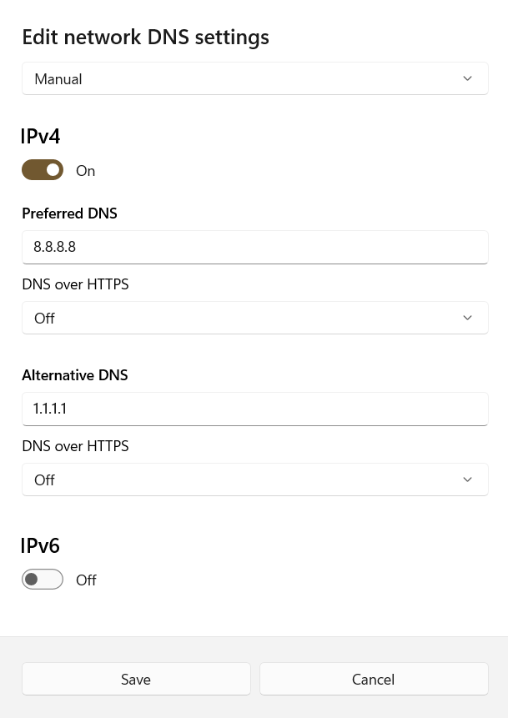
3.2. Network Traffic Collection
- Step 1: Close all user programs exchanging network data except the web browser.
- Step 2: Clear the browser cache

- Mozilla Firefox: Press Ctrl + Shift + Del. Select the options as shown below and click Clear.
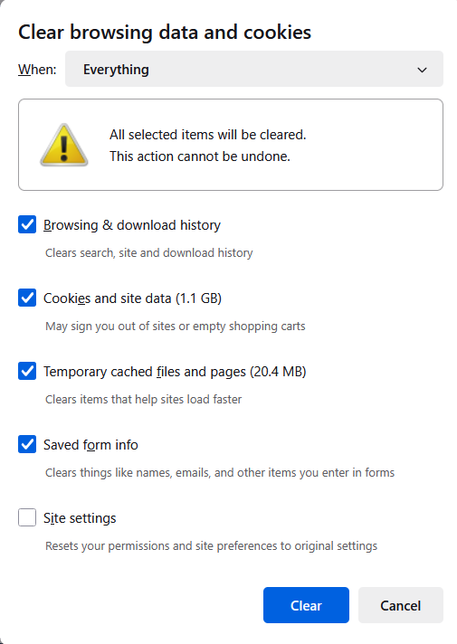
- Google Chrome: Press Ctrl + Shift + Del. Select the options as shown below and click Delete data.
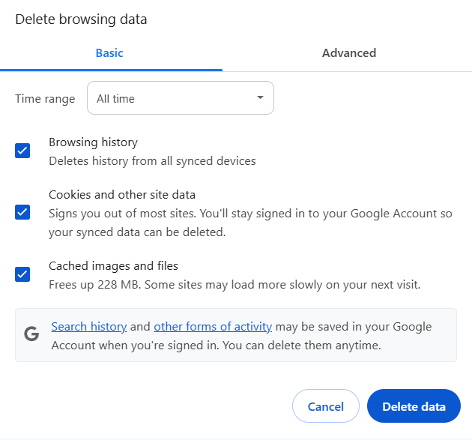
- Step 3: In the Command Prompt window, execute the command ipconfig /flushdns.
- Step 4: Launch Wireshark and select the appropriate network interface for packet capture.
- Step 5: In the web browser, open a private browsing window:
- Mozilla Firefox: Press Ctrl + Shift + P.
- Google Chrome: Press Ctrl + Shift + N.
Access the following address: http://nct.soict.hust.edu.vn/mmt/lab05/
- Step 6: After the browser finishes loading the webpage (approximately 15-30 seconds), stop the packet capture in Wireshark.
Notes:
- In Wireshark’s menu, select "Analyze > Enabled Protocols." Ensure that DNS and HTTP are checked.
- If the captured traffic file on the practice machine lacks DNS protocol packets, repeat from Step 2.
- Captured packets may have parameters differing from the illustrative images. This is normal and does not affect the exercise.
- Step 7: Save the traffic file as lab05.pcapng and submit it with the report.

3.3. Analyze Data Transmission in DNS
Use the traffic file from Section 3.2 to observe and answer the questions.
- Step 1: Enter dns into Wireshark’s Filter field to filter captured DNS messages, as illustrated below.
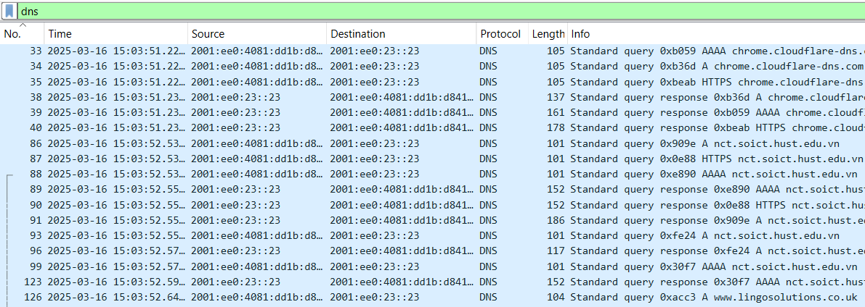
- Step 2: Find the DNS packet sent by the browser to request resolution of the accessed website’s domain name and answer Question 1.
Note: If no such packet is found, repeat the steps in Section 3.2.
Question 1 (1 point): Identify the following information in the message:
- Packet number (No.):
- Transport layer protocol used to encapsulate the message:
- Source IP address:
- Source application port number:
- Destination IP address:
- Destination port number? Which service does this port correspond to?
- Transaction ID of the query session:
- Query type (Type):
- Step 3: Find the DNS Response message replying to the request in Step 2 to observe and answer Question 2.
Question 2 (1 point): Identify the following information in the message
- Packet number (No.):
- Transport layer protocol used to encapsulate the message:
- Source IP address:
- Source application port number:
- Destination IP address:
- Destination port number:
- Transaction ID of the query session:
- Query type (Type):
- Queried domain name:
- IP address of the queried domain name (if available):
Conclusion: Which IP address is the domain nct.soict.hust.edu.vn resolved to?
- Step 4: Observe the entire domain name query process and answer the Question 3?
Question 3 (1 point):
- Which transport layer protocol does the DNS resolution service use to transmit its messages?
- Before performing the domain name query, do the parties establish a connection?
- After sending a DNS message, can each party confirm successful receipt by the other?
- Why, in addition to the query for nct.soict.hust.edu.vn triggered by accessing http://nct.soict.hust.edu.vn/mmt/lab05/, are there queries for other domain names?

3.4. Analyze HTTP Data Transmission
3.4.1. Analyze HTTP Traffic
Use the traffic file from Section 3.2 to observe and answer the questions.
- Step 1: Enter http into Wireshark’s Filter field. You will observe the HTTP packets exchanged by the workstation over the network, as illustrated below.
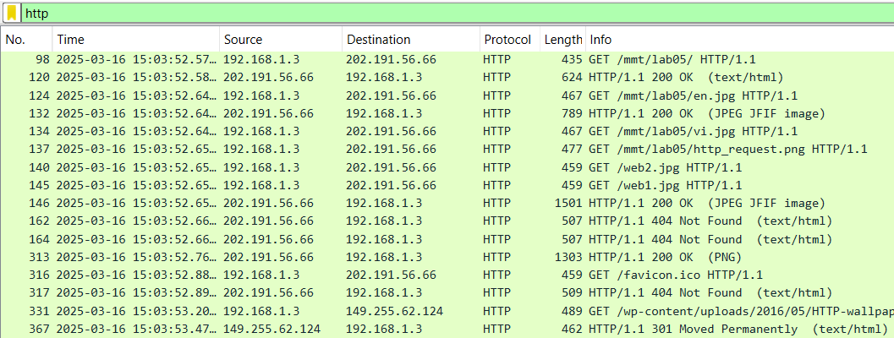
- Step 2: Observe the HTTP messages exchanged between the workstation and the website nct.soict.hust.edu.vn and answer Question 4.
Question 4 (1 point): How many HTTP Request messages were sent? List the following details about the HTTP messages between the workstation and the web server nct.soict.hust.edu.vn:
HTTP Request |  |  | HTTP Response
No. | Method | Requested object | No. | Response Code | Description
Among the HTTP Request messages, are there any sent consecutively without waiting for a response from the server? If so, why does the browser on the workstation behave this way?
- Step 3: Select the first HTTP Request message sent by the workstation to the web server nct.hust.edu.vn and answer Question 5.
Câu hỏi 5(1 điểm): Provide the following information about the message:
- Transport layer protocol used to transmit the message:
- Destination application port number:
- HTTP protocol version used by the workstation:
- Explain the meaning of the following headers in the message and provide their values:
- Host:
- Connection:
- Step 4: Locate the HTTP Response message from the web server replying to the request in Step 3 and answer Question 6.
Question 6 (1 point): Provide the following information about the response message:
- HTTP protocol version used by the server:
- Explain the meaning of the following headers in the message and provide their values:
- Accept-Ranges:
- Content-Length:
- Keep-Alive:
- Connection:
- Content-Type:
- Which TCP packet sequence numbers encapsulate this message?
- After this message is sent, is the TCP connection maintained?
- Step 5: Observe the entire accessing the website and answer the Question 7?
Question 7 (1 point): Besides exchanging data with the website nct.soict.hust.edu.vn, which other website’s domain name does the workstation send HTTP Request messages to? Why are these messages sent? (Hint: Review the payload content of the HTTP Response message from Step 4.)
Examine the headers of the above HTTP Request message and provide the value of the Referer header. What is the meaning of this header?

3.4.2. Analyze TCP traffic
Use the traffic file from Section 3.2 to observe and answer the questions.
- Step 1: Assume that in Section 3.3, you observed that the IP address resolved from the domain name nct.soict.hust.edu.vn of the web server is X. Enter ip.addr == X (Note: Replace X with the observed IP address) into Wireshark’s Filter field. You will observe the messages exchanged between the workstation and the web server, as illustrated below.
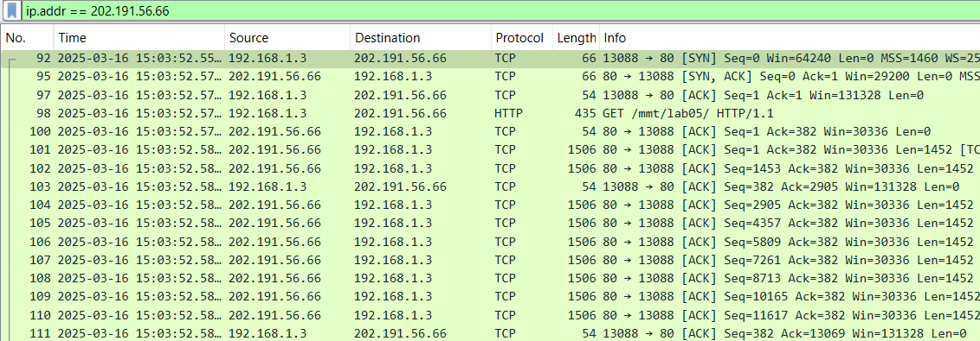
Question 8(1 point): Before the first HTTP message is sent to the server nct.soict.hust.edu.vn, did the workstation and server perform a TCP connection establishment process? Describe the packets exchanged by both parties during this process and complete the table below:
Initiator’s IP address: …………………….. Responder’s IP address: ……………………..
Initiator’s port number: …………………. Responder’s port number: ………………….
For each packet in the connection establishment process, provide the following parameters:

No. | Flags field in binary | Set flags | Sequence number | ACK number | Payload length

- Step 2: Select any TCP packet encapsulating the content of the HTTP Request message from Question 5 and answer Question 9.
Question 9(1 point):
- Identify the following parameters of the packet:
- Packet number (No.):
- Source IP address:
- Destination IP address:
- Source port number:
- Destination port number:
- Sequence Number:
- ACK Number:
- TCP header size:
- Data size:
- Flags set:
Are the address parameters of this packet consistent with those in the connection establishment process?
- Was this packet successfully delivered to the destination? Find the acknowledgment packet to prove it and answer the following:
- Acknowledgment packet number (No.):
- Source IP address:
- Destination IP address:
- Source port number:
- Destination port number:
- Sequence Number:
- ACK Number:
- TCP header size:
- Data size:
- Flags set:
Which observed information above proves the transmission was successful?
- Step 3: Observe the TCP connection termination process.
Question 10(1 point): Identify the packets used to terminate the connection observed in Question 8. For each packet in this process, provide the following parameters:
No. | Flags field in binary | Set flags | Sequence number | ACK number | Payload length

